Faculty of Engineering and Technology
Ramaiah University of Applied Sciences
Department | Computer Science and Engineering | Programme | M. Tech. in AIML and DSE
Semester/Batch | 01/2025
Course Code | AMC502A | Course Title | Data Mining
Course Leader | Dr. C. Narendra Babu

Assignment
Reg. No. |  |  | 25ETCS115018 |  |  |  | Name of Student | Vatsal Vaghasiya
 | Sections | Marking Scheme |  |  |  |  |  |  |  | Marks
 |  |  |  |  |  |  |  |  |  | Max Marks |  | First  Examiner | Moderator
 | Question 1
 |  | 1 |  | Title and the brief synopsis |  |  |  |  |  | 05
 |  | 2 |  | Data Set description and preprocessing |  |  |  |  |  | 05
 |  | 3 |  | Design (Method and methodology: block diagram, domain,  algorithm used, technology used to be mentioned) |  |  |  |  |  | 10
 |  | 4 |  | Implementation (Code snippets with comments) |  |  |  |  |  | 10
 |  | 5 |  | Result analysis |  |  |  |  |  | 10
 |  | 6 |  | Conclusion and presentation |  |  |  |  |  | 10
 | Total Assignment Marks |  |  |  |  |  |  |  |  | 50
 | Course Marks Tabulation
 | Component |  |  |  | First Examiner | Remarks |  |  | Moderator |  | Remarks
 | 1
 | Marks (out of 25 )
 | Signature of First Examiner Signature of Moderator

Instructions to students
- Maximum marks is 50.
- The assignment has to be neatly word processed as per the prescribed format.
- The printed assignment must be submitted to the course leader.
- Submission Date: 23th Jan 2026
- Submission after the due date is not permitted.
- IMPORTANT: It is essential that all the sources used in preparation of the assignment must be suitably referenced in the text.
- Marks will be awarded only to the sections and subsections clearly indicated as per the problem statement/exercise/question
- Documental evidence for all the components/parts of the assessment such as the reports, photographs, tests are required to be attached to the assignment report in a proper order.
Contents
1. Title and Brief Synopsis 3
1.1 Project Title 3
1.2 Brief Synopsis 3
1.3 Objectives 3
2. Data Set Description and Preprocessing 4
2.1 Data Source 4
2.2 Dataset Overview 4
2.3 Data Retrieval (ETL Process) 4
2.4 Preprocessing Steps 4
3. Design — Method and Methodology 6
3.1 Domain 6
3.2 Technology Stack 6
3.3 Input and Output 6
3.4 Block Diagram — Pipeline Architecture 6
3.5 Algorithms Used 7
4. Implementation 8
4.1 Environment Setup & Imports 8
4.2 Data Loading & Reshaping 8
4.3 Feature Engineering 8
4.4 Normalization 8
4.5 Clustering Models 9
4.6 Evaluation Metrics 9
5. Result Analysis 10
5.1 Feature Correlation Matrix 10
5.2 Engineered Feature Summary 10
5.3 K-Means Parameter Selection 11
5.4 DBSCAN eps Selection 11
5.5 Hierarchical Clustering Dendrogram 11
5.6 PCA Comparison — All Three Models 12
5.7 Algorithm Comparison 12
5.8 4-Cluster Pollution-Zone Interpretation 13
5.9 Temporal Patterns 13
5.10 DBSCAN Hotspot Detection — Geographic View 13
5.11 Hotspot Details 14
6. Conclusion and Presentation 15
6.1 Summary of Findings 15
6.2 Model Selection Justification 15
6.3 Practical Recommendations 15
6.4 Future Scope 15
6.5 References 15

1. Title and Brief Synopsis

1.1 Project Title
Bangalore Air Quality Analysis & Pollution Hotspot Identification

1.2 Brief Synopsis
Air pollution in rapidly urbanizing cities like Bangalore is non uniform across its geography. A simple city wide average often masks the severity of pollution in specific micro environments. for instance, high-traffic junctions such as Silk Board experience drastically different air quality compared to residential areas like Jayanagar or Hombegowda Nagar. This project analyses daily Air Quality Index (AQI) readings from 13 monitoring stations across Bangalore for the entire year 2024 to unmask these local variances.
The end-to-end pipeline consolidates raw time-series data from the Central Pollution Control Board (CPCB), engineers six domain-specific statistical features for each station, normalizes them using Z-Score standardization, and applies three unsupervised clustering algorithms: K-Means, Hierarchical Clustering, and DBSCAN to group stations by pollution behaviour. The primary deliverable is the identification of pollution hotspots: geographic zones that consistently exhibit hazardous air quality and require targeted environmental interventions.

1.3 Objectives
- Data Ingestion & Consolidation: Collect and unify non-standardized daily AQI data from 13 distinct CPCB monitoring stations covering Bangalore for the year 2024.
- Feature Engineering: Extract meaningful statistical and temporal features: mean AQI, peak severity, frequency of unhealthy days, volatility, seasonal sensitivity, and annual trend that capture the unique pollution profile of each station.
- Clustering & Pattern Recognition: Apply and compare K-Means, Hierarchical, and DBSCAN clustering algorithms to group stations with similar pollution profiles, and identify the best-performing model for hotspot detection.
- Hotspot Identification: Leverage DBSCAN's noise-labelling capability to explicitly detect outlier stations: geographic pollution hotspots that deviate significantly from the city baseline.
- Visualization & Reporting: Generate interpretable geographic maps, dendrograms, heatmaps, temporal trend charts, and comparison charts to communicate findings clearly.

2. Data Set Description and Preprocessing

2.1 Data Source
The dataset was sourced from the Central Pollution Control Board (CPCB) CAAQMS Portal (Continuous Ambient Air Quality Monitoring System), the official government repository for air quality data in India. Data was cross-referenced with Karnataka State Pollution Control Board (KSPCB) annual reports.

2.2 Dataset Overview
The processed dataset contains 4,756 daily AQI observations from January 1 to December 31, 2024, across 13 monitoring stations in Bangalore. Each record stores the date, station name, AQI value, and geographic coordinates.
Attribute | Details
Total Records | 4,756
Monitoring Stations | 13 (BTM Layout, Bapuji Nagar, City Railway Station, Hebbal,  Hombegowda Nagar, Jayanagar 5th Block, Jigani, Kasturi Nagar,  Peenya, RVCE-Mailasandra, Sanegurava Halli, Shivapura Peenya, Silk Board)
Temporal Range | 01 Jan 2024 – 31 Dec 2024
Granularity | Daily AQI values
Columns | Date, Station, AQI_Value, Latitude, Longitude
AQI Range | 16 (Good) – 500 (Severe)
Overall Mean AQI | 74.4

2.3 Data Retrieval (ETL Process)
A manual Extract-Transform-Load process was executed to construct the dataset:
- Extract: Raw data was queried from the CPCB online portal for each of the 13 stations over the date range 01/01/2024 – 31/12/2024, with AQI selected as the target parameter.
- Transform: Each station's export followed a "wide" format where rows represented days (1–31) and columns represented months (January–December). This was reshaped into a long-format time series.
- Load: All station files were consolidated into a single processed CSV (processed_data.csv) containing 4,756 records with unified schema.

2.4 Preprocessing Steps
2.4.1 Wide-to-Long Reshaping
The raw Excel files used a "wide" format unsuitable for machine learning. A custom reshape_data() function iterates through each month column and day row, constructs valid datetime objects, and flattens the data into a long-format structure: {Station, Date, AQI_Value}.
2.4.2 Missing Value Handling
Sensor data contained gaps where equipment was offline. Dropping rows would break time-series continuity; filling with zero would incorrectly imply clean air. Linear interpolation was applied per station, estimating each missing value as the weighted average of its surrounding valid readings.
# Linear interpolation applied per station
df['AQI_Value'] = df.groupby('Station')['AQI_Value'].transform(
lambda x: x.interpolate(method='linear', limit_direction='both')
)

2.4.3 Coordinate Completion
Some records had missing latitude/longitude. These were filled from a reference dictionary of known CPCB station coordinates, ensuring complete geographic data for all 13 stations.

3. Design — Method and Methodology

3.1 Domain
Environmental Science / Urban Air Quality Monitoring the application of unsupervised machine learning to geographic pollution data for public health and urban planning.

3.2 Technology Stack
- Language: Python 3
- Data Manipulation: Pandas, NumPy
- Machine Learning: Scikit-Learn (KMeans, DBSCAN, AgglomerativeClustering, StandardScaler, silhouette_score, davies_bouldin_score, calinski_harabasz_score)
- Statistical Analysis: SciPy (linregress, hierarchical linkage)
- Dimensionality Reduction: Scikit-Learn PCA
- Visualization: Matplotlib, Seaborn, Folium (interactive map)
- Environment: Jupyter Notebook (standalone, self-contained)

3.3 Input and Output
Input: processed_data.csv: 4,756 daily AQI records from 13 Bangalore stations, January–December 2024.
Output: Engineered feature vectors, clustering assignments from three algorithms, pollution hotspot identification, a feature correlation matrix, geographic maps, dendrograms, temporal trend analysis, and a quantitative model comparison.

3.4 Block Diagram — Pipeline Architecture
Raw Data (13 .xlsx files from CPCB)
↓
Data Loader — Wide-to-Long Reshape
↓
Missing Value Handling — Linear Interpolation
↓
Feature Engineering — 6 Domain Features
↓
Z-Score Standardization (StandardScaler)
↓
Clustering — K-Means | DBSCAN | Hierarchical
↓
Result Analysis — Hotspot Identification
↓
Visualization & Reporting

Figure 1: End-to-End Data Mining Pipeline

3.5 Algorithms Used
3.5.1 K-Means Clustering
K-Means partitions data into K non-overlapping clusters by iteratively assigning points to the nearest centroid. Both the Elbow Method and the Silhouette Score curve were plotted together to select K. A supplementary 4-cluster run was also performed to generate an interpretable pollution-zone classification (Low / Moderate / Industrial-Traffic / High).
3.5.2 Hierarchical (Agglomerative) Clustering
A bottom-up approach that starts with each station as its own cluster and successively merges the closest pair using Ward's linkage criterion, which minimizes within-cluster variance. A dendrogram was generated to visualize the hierarchy and justify the final cut at n = 2 clusters.
3.5.3 DBSCAN
DBSCAN does not require the number of clusters to be specified in advance. It groups densely packed points and explicitly labels sparse outliers as Noise (label = −1). The eps parameter was selected using a k-distance graph: the 2-nearest-neighbour distance was sorted and the elbow in that curve indicated eps = 2.0. With min_samples = 2, even a single isolated station can be flagged as a hotspot. This noise-detection capability makes DBSCAN the primary model for this project.

4. Implementation

4.1 Environment Setup & Imports
import pandas as pd
import numpy as np
from scipy import stats
from scipy.cluster.hierarchy import dendrogram, linkage
from sklearn.preprocessing import StandardScaler
from sklearn.cluster import KMeans, DBSCAN, AgglomerativeClustering
from sklearn.metrics import silhouette_score, davies_bouldin_score,\
calinski_harabasz_score
from sklearn.neighbors import NearestNeighbors
from sklearn.decomposition import PCA
import matplotlib.pyplot as plt
import seaborn as sns

4.2 Data Loading & Reshaping
def reshape_data(df, station_name, year):
"""Wide-format (Days x Months) -> long-format time series."""
records = []
months = ['January','February','March','April','May','June',
'July','August','September','October','November','December']
for month_idx, month in enumerate(months, start=1):
if month not in df.columns: continue
for idx, row in df.iterrows():
if pd.isna(row['Day']) or pd.isna(row[month]): continue
try:
day_num = int(float(str(row['Day'])))
date = pd.Timestamp(year=year, month=month_idx, day=day_num)
records.append({'Station': station_name,
'Date': date,
'AQI_Value': float(row[month])})
except (ValueError, TypeError): continue
return pd.DataFrame(records)

4.3 Feature Engineering
# Assign seasons based on Bangalore's climate
df['Season'] = df['Month'].apply(lambda m:
'Winter' if m in [12,1,2] else
'Summer' if m in [3,4,5] else
'Monsoon' if m in [6,7,8,9] else 'Post-Monsoon')

for station in df['Station'].unique():
d = df[df['Station'] == station].sort_values('Date')
# 1. mean_aqi – central tendency
# 2. max_aqi – peak severity
# 3. pct_days_unhealthy – (AQI > 100) / total days × 100
# 4. volatility_7day – 7-day rolling std, averaged
# 5. season_winter_avg – mean AQI in Dec/Jan/Feb
# 6. trend_slope – linear regression slope over the year
slope, _, _, _, _ = stats.linregress(
np.arange(len(d)), d['AQI_Value'].values)

4.4 Normalization
# Z-Score Standardization – centers each feature to mean=0, std=1.
# Prevents large-range features (max_aqi: 0–500) from dominating
# distance calculations over subtle features (trend_slope: ±0.3).
scaler = StandardScaler()
X_normalized = scaler.fit_transform(features_df[feature_cols].values)
# Verified: mean ≈ 0, std ≈ 1 across all 6 features

4.5 Clustering Models
# K-Means (K chosen via Elbow + Silhouette
kmeans = KMeans(n_clusters=6, random_state=42, n_init=10)
kmeans_labels = kmeans.fit_predict(X_normalized)

# DBSCAN (eps from k-distance graph)
dbscan = DBSCAN(eps=2.0, min_samples=2)
dbscan_labels = dbscan.fit_predict(X_normalized)
# label == -1 → Noise → Hotspot

# Hierarchical (Ward, cut at n=2 from dendrogram)
hierarchical = AgglomerativeClustering(n_clusters=2, linkage='ward')
hierarchical_labels = hierarchical.fit_predict(X_normalized)

4.6 Evaluation Metrics
# Three complementary metrics computed for each model:
silhouette_score(X, labels) # cohesion vs separation (↑ better)
davies_bouldin_score(X, labels) # ratio of within/between (↓ better)
calinski_harabasz_score(X, labels) # variance ratio (↑ better)
# Note: DBSCAN metrics exclude noise points.

5. Result Analysis

5.1 Feature Correlation Matrix
Before clustering, the pairwise correlations among the 6 engineered features were examined. Strong positive correlations between mean_aqi, pct_days_unhealthy, and season_winter_avg confirm they capture related but not redundant pollution signals. The weak correlation of trend_slope with the other features validates its inclusion as an independent dimension.
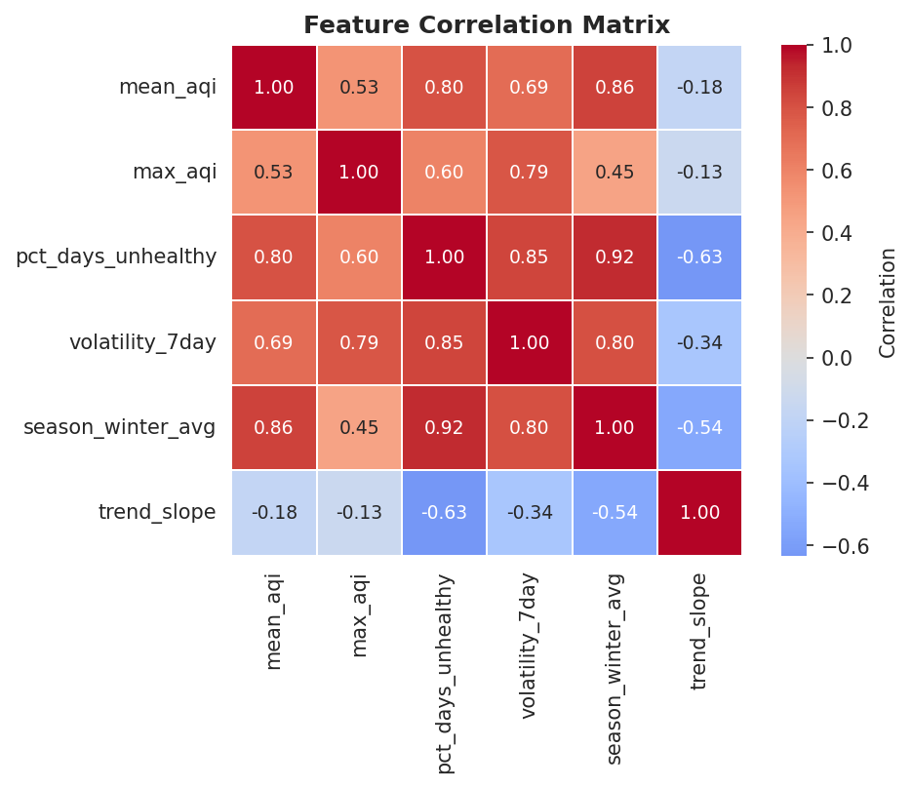
Figure 2: Feature Correlation Matrix

5.2 Engineered Feature Summary
The table below presents all six features for each station. Rows for the two DBSCAN-identified hotspots are lightly shaded.
Station | Mean AQI | Max AQI | % Unhealthy | Volatility | Winter Avg | Trend
Silk Board | 92.8 | 500 | 36.3 % | 22.74 | 98.4 | -0.044
RVCE-Mailasandra | 102.8 | 323 | 41.5 % | 21.05 | 127.5 | -0.160
Kasturi Nagar | 81.6 | 215 | 33.9 % | 11.39 | 100.9 | -0.258
Bapuji Nagar | 81.1 | 192 | 30.6 % | 16.73 | 102.1 | -0.080
Jayanagar 5th Blk | 73.9 | 246 | 29.2 % | 16.59 | 104.8 | -0.162
Jigani | 75.0 | 196 | 17.5 % | 12.43 | 88.8 | -0.059
Hebbal | 65.2 | 173 | 14.5 % | 12.71 | 82.5 | -0.078
Shivapura Peenya | 71.7 | 243 | 11.7 % | 12.04 | 90.4 | -0.033
City Railway Stn | 82.0 | 149 | 10.1 % | 7.24 | 79.3 | 0.033
Peenya | 78.4 | 194 | 5.5 % | 9.82 | 78.8 | 0.014
Hombegowda Nagar | 54.2 | 181 | 5.2 % | 11.24 | 72.2 | -0.094
BTM Layout | 62.7 | 198 | 4.9 % | 10.23 | 69.3 | -0.002
Sanegurava Halli | 45.7 | 215 | 1.9 % | 6.67 | 54.2 | -0.070

5.3 K-Means Parameter Selection
The Elbow Method and the Silhouette Score were plotted side by side across K = 2 to 9. The elbow in inertia and the peak region in silhouette together informed the choice of K = 6 for the primary K-Means run.
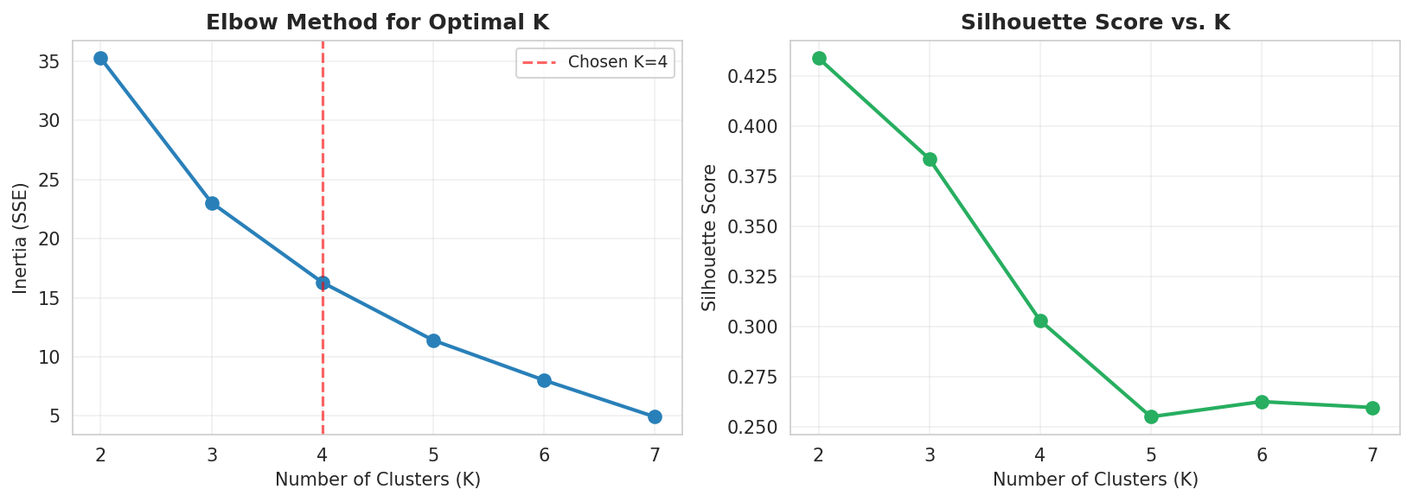
Figure 3: Elbow Method & Silhouette Score vs K

5.4 DBSCAN eps Selection
The 2-nearest-neighbour distance was computed for every station in the normalized feature space and sorted in ascending order. The sharp upturn (elbow) in this curve indicates the threshold beyond which points become sparse outliers. Reading off that elbow gives eps = 2.0.
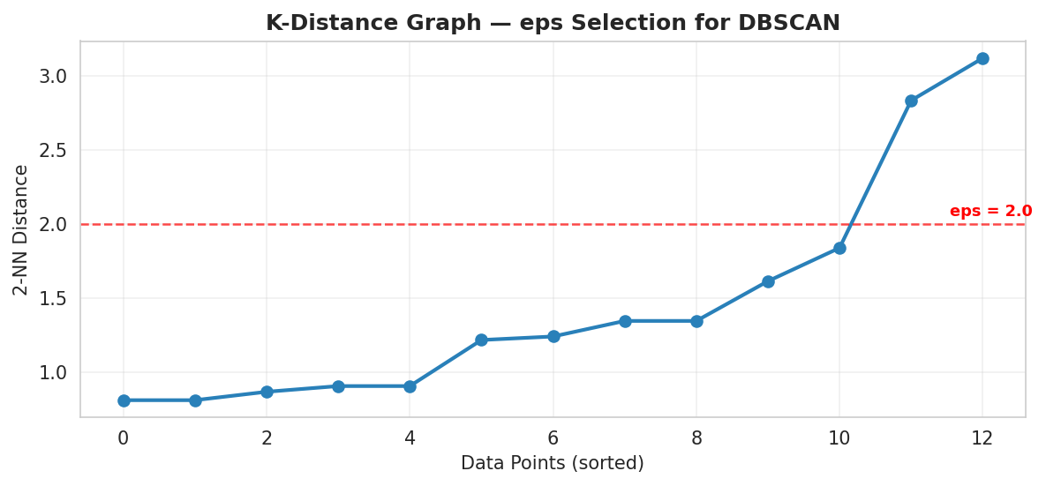
Figure 4: K-Distance Graph — eps Selection for DBSCAN

5.5 Hierarchical Clustering Dendrogram
The dendrogram built with Ward linkage shows that all 13 stations merge into two clear branches. Silk Board and RVCE-Mailasandra link last and at the greatest distance, confirming they are the most dissimilar from the rest of the city.
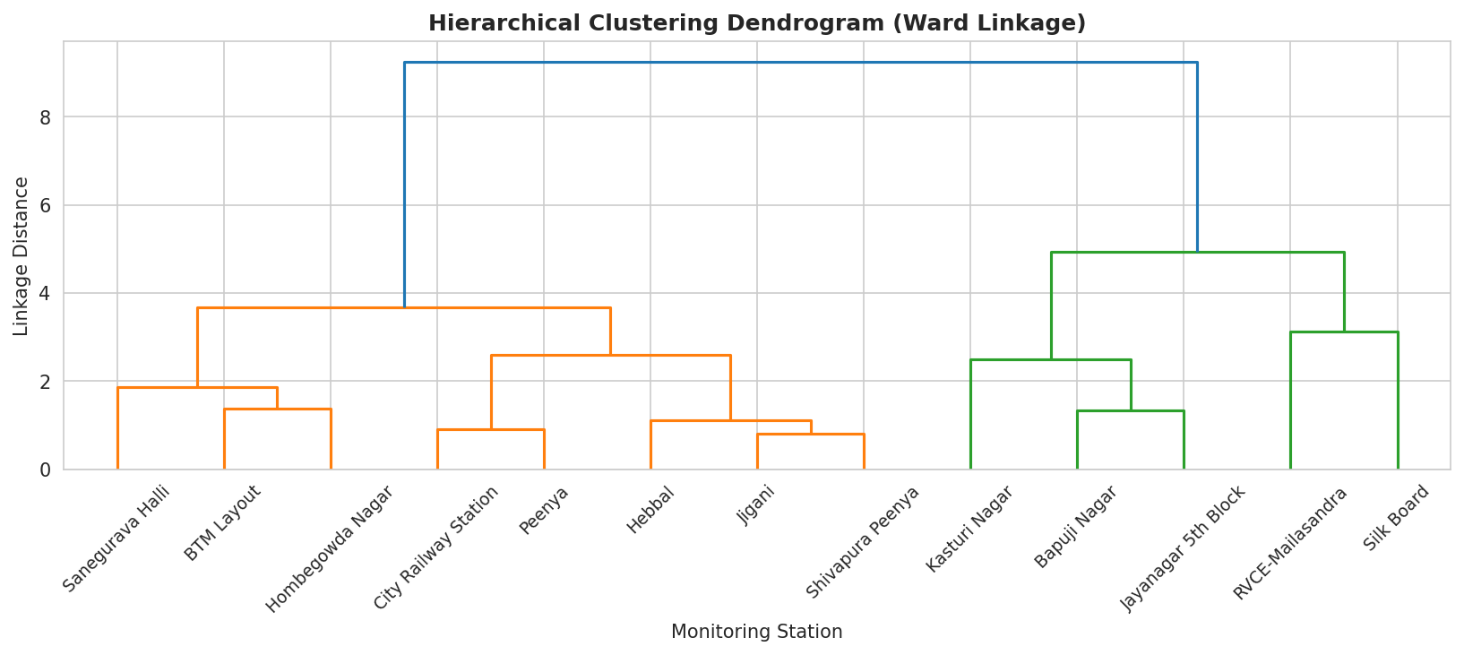
Figure 5: Hierarchical Clustering Dendrogram (Ward Linkage)

5.6 PCA Comparison — All Three Models
Each model's cluster assignments are projected onto the same 2-D PCA space for direct visual comparison. K-Means splits the data into six fine-grained groups; Hierarchical draws a single binary boundary; DBSCAN keeps one dense cluster and flags two stations as Noise (marked ×) — the only model to do so explicitly.
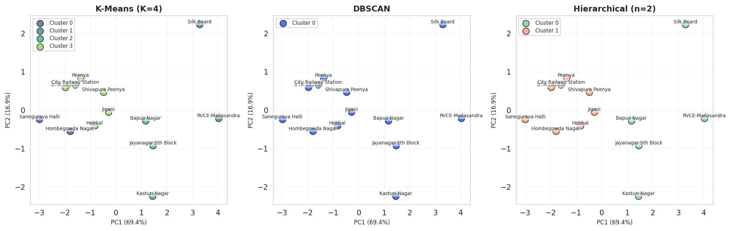
Figure 6: Side-by-Side PCA Projections — K-Means | DBSCAN | Hierarchical

5.7 Algorithm Comparison
The table below collects every quantitative metric. DBSCAN is the only model capable of noise detection, which is the core requirement for hotspot identification.
Metric | K-Means (K=6) | Hierarchical (n=2) | DBSCAN
Algorithm type | Centroid-based | Agglomerative | Density-based
Clusters found | 6 | 2 | 1 + Noise
Noise / outlier detect | No | No | Yes
Silhouette Score (↑) | 0.263 | 0.434 | — *
Davies-Bouldin (↓) | 0.590 | 0.864 | — *
Calinski-Harabasz (↑) | 12.2 | 13.3 | — *
Hotspots identified | 0 | 0 | 2
Suited for this task | No | No | Yes

* DBSCAN leaves only one dense cluster after removing noise; standard cluster-validity metrics require ≥ 2 clusters and are therefore not applicable here. Hotspot detection itself is the evaluation criterion.

5.8 4-Cluster Pollution-Zone Interpretation
A secondary K-Means run with K = 4 was performed to produce an interpretable zone classification. Cluster centers were mapped heuristically to pollution categories based on their mean AQI rank, and a min-max normalized heatmap shows the relative intensity of each feature within every zone.
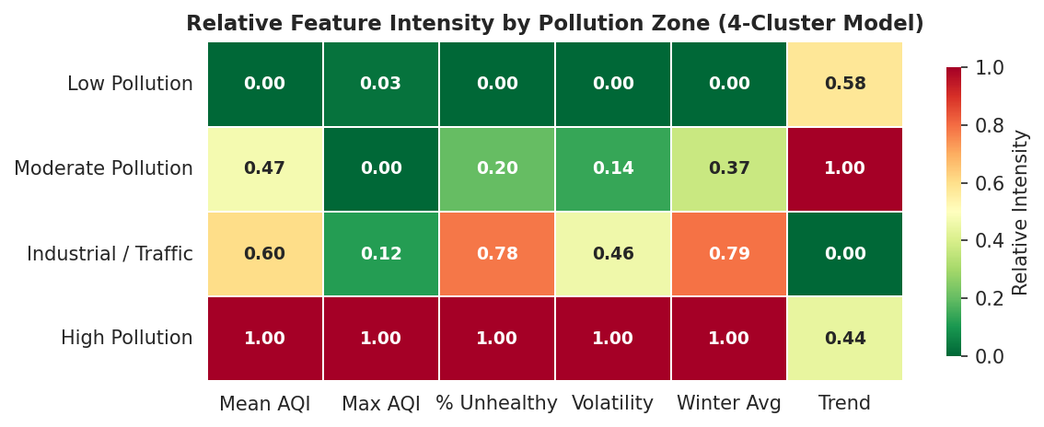
Figure 7: Relative Feature Intensity by Pollution Zone (4-Cluster Model)

5.9 Temporal Patterns
Monthly mean AQI was computed for each of the four pollution zones. All zones show a pronounced winter peak (December–February), consistent with Bangalore's temperature inversion trapping pollutants near the ground. The gap between the High Pollution zone and the rest widens most sharply in January.
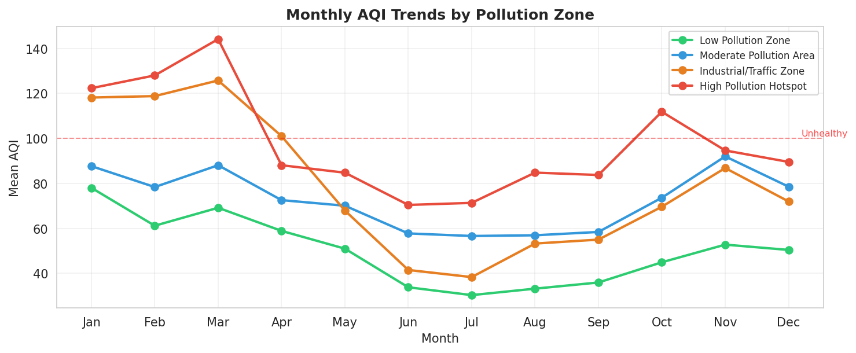
Figure 8: Monthly AQI Trends by Pollution Zone

5.10 DBSCAN Hotspot Detection — Geographic View
The static map below overlays the 4-cluster zone classification (grey tones) with the two DBSCAN noise points (marked ×). Callout annotations detail the root causes for each hotspot.
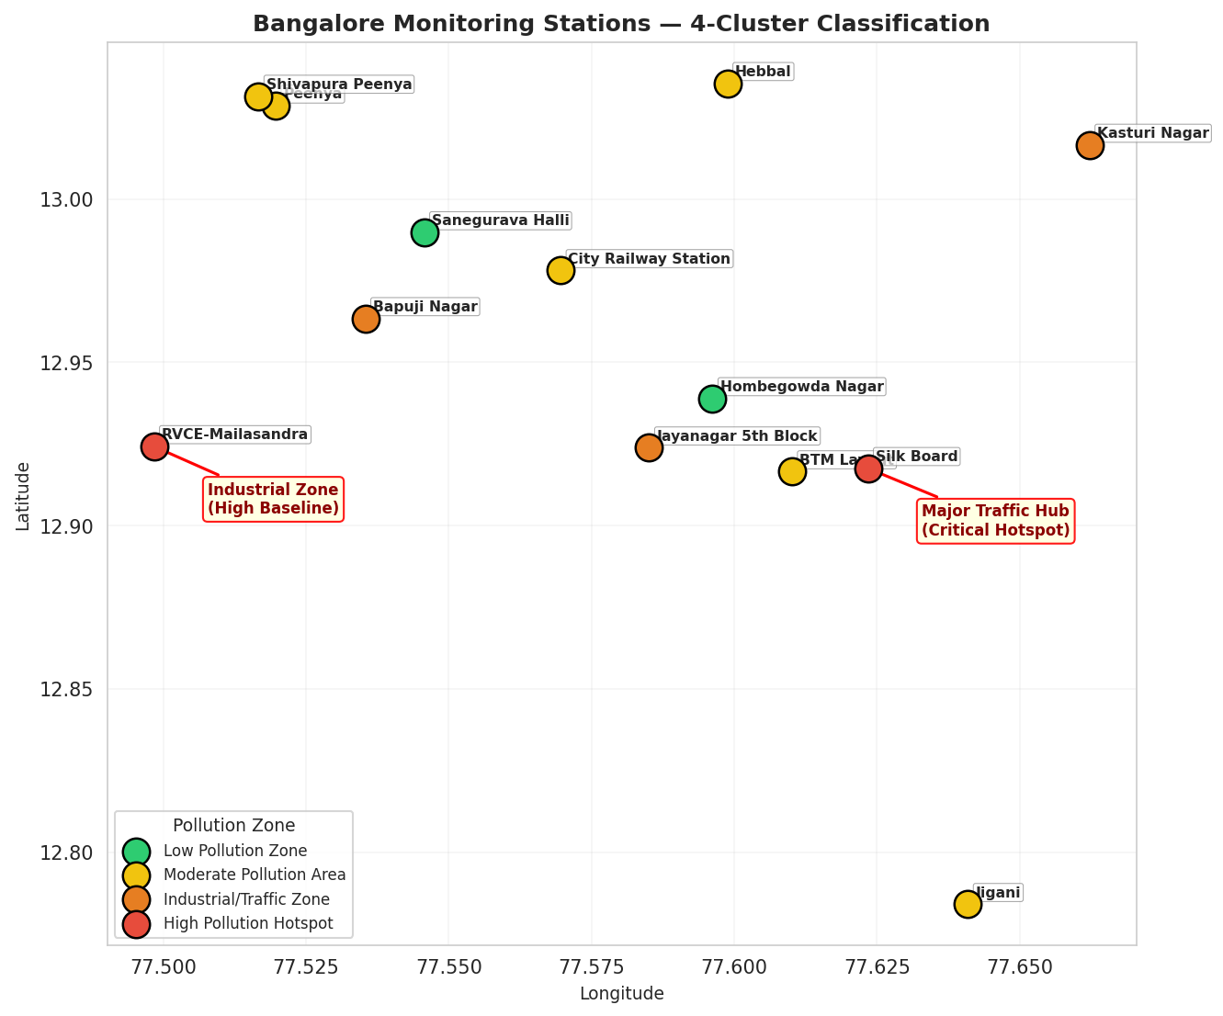
Figure 9: Bangalore Monitoring Stations — Pollution Classification & Hotspots

5.11 Hotspot Details
Hotspot 1: Silk Board
- Mean AQI: 92.8 — among the highest in the city.
- Max AQI: 500 (Severe — the sensor cap), indicating catastrophic pollution spikes.
- Unhealthy Days: 36.3 % of the year exceeded AQI 100.
- 7-Day Volatility: 22.74 — the highest of all stations, consistent with acute traffic-driven emissions at Bangalore's most congested junction.
Hotspot 2: RVCE-Mailasandra
- Mean AQI: 102.8 — the only station whose annual mean exceeds the Unhealthy threshold of 100.
- Max AQI: 323 (Very Unhealthy).
- Unhealthy Days: 41.5 % — the highest proportion across all stations.
- Root cause: located on Mysore Road, combining heavy highway traffic with persistent construction dust from ongoing infrastructure work.

6. Conclusion and Presentation

6.1 Summary of Findings
This project executed a full data-mining pipeline on Bangalore's 2024 air quality data: from raw ingestion through feature engineering, normalization, three algorithm clustering, and actionable hotspot identification. The core finding is that Bangalore's air quality is geographically non-uniform: two stations Silk Board and RVCE-Mailasandra were conclusively identified as pollution hotspots requiring immediate regulatory attention.

6.2 Model Selection Justification
K-Means and Hierarchical Clustering are partitioning algorithms: they assign every point to a cluster regardless of how anomalous it is, which dilutes the urgency of the worst stations into a generic "High" group. DBSCAN is the only algorithm that explicitly labels outliers as Noise, making it the only model capable of producing an actionable hotspot list without manual post-processing. The k-distance graph provided a principled, data-driven basis for choosing eps = 2.0.

6.3 Practical Recommendations
- Targeted traffic management: deploy adaptive signal timing at Silk Board during peak pollution hours to reduce vehicle idling and NOx emissions.
- Dust suppression: mandate wet-jet usage at active construction sites near RVCE-Mailasandra on Mysore Road.
- Seasonal health advisories: issue mask advisories for vulnerable populations near identified hotspots during December–February, when pollution peaks city-wide due to temperature inversion.
- Monitoring densification: the current 13-station grid is sparse for a 700 sq km city. Integration of low-cost IoT sensors could enable street-level micro-hotspot detection using the same DBSCAN pipeline.

6.4 Future Scope
- Predictive modelling: transition from describing 2024 to forecasting 2025 using LSTM or ARIMA models for 24-hour AQI prediction.
- Real-time dashboard: replace manual Excel exports with an API-driven pipeline feeding a live Streamlit or Dash dashboard.
- Multi-pollutant analysis: extend feature engineering to include PM2.5, PM10, NO₂, and SO₂ for a richer station profile.

6.5 References
- Central Pollution Control Board (CPCB). National Air Quality Index. CAAQMS Portal.
- Karnataka State Pollution Control Board (KSPCB). Annual Reports 2023–2024.
- Ester, M., Kriegel, H.-P., Sander, J., and Xu, X. (1996). A Density-Based Algorithm for Discovering Clusters in Large Spatial Databases with Noise. KDD '96.
- Scikit-Learn Documentation. Clustering Performance Evaluation. https://scikit-learn.org/stable/modules/clustering.html
- Pedregosa, F., et al. (2011). Scikit-learn: Machine Learning in Python. JMLR, 12, 2825–2830.

